**User Manual**

**Module - Restaurant (Restaurant User)**

**June 2022, Version-1.0**



**Sustainable Outreach and Universal Leadership Limited**

**Sign off Date     Signature Client Signature Consulting**

Table of Contents

[Module: Restaurant 3](https://docs.google.com/document/d/198pC5pz8fhu2hql7Lhit7WpfHo7yllOk/edit" \l "heading=h.1fob9te)

1. Restaurant Order Entry 4

4. Restaurant Reservation 5

1. **Restaurant Order Entry**

The Restaurant Order Entry is the screen where the waiters will punch in orders related to a particular table.

This screen makes it easy for the waiters in your restaurant to punch in orders from various tables.

**1.1 To access the Sales Invoice list, go to:**

Home > Restaurant Order > Your Shortcuts > Restaurant Order Entry

**1.2 Prerequisite**

Restaurant Table

Item

**1.3 How to Create a Restaurant?**

1. Go to Restaurant Order Entry and Click on Add Restaurant Order Entry.

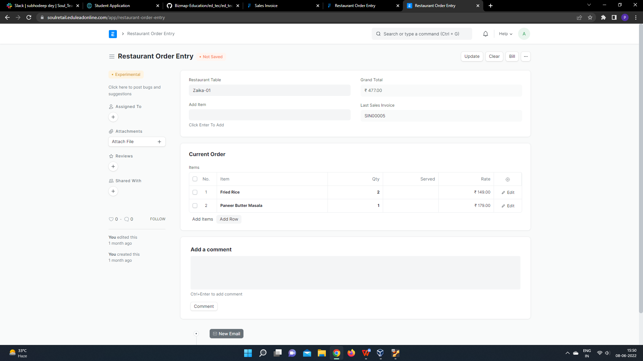

2. When the guest places an order, the waiter will select the table number and add the items in the Order Entry.

3. To place an order you can select an item and click the enter key so that the item will be updated in the items table.

This can be changed until it is time for the bill. Unless you bill a table, you can change the items and they will automatically appear when you select the table ID.

### **Billing**

When it is time for billing, you just choose the bill and you can select the customer and mode of payment. On saving, a Sales Invoice is generated and the order section becomes empty.

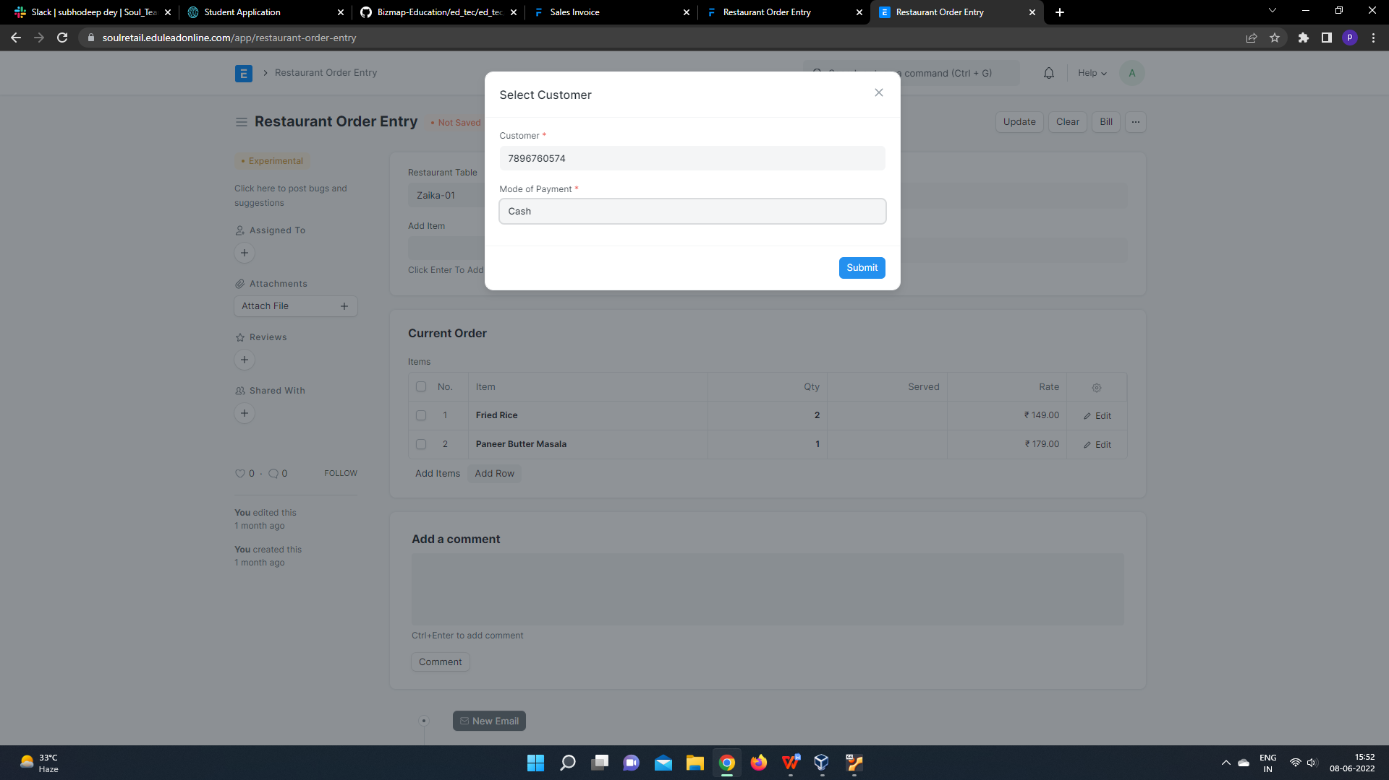

To print the invoice, you can click on the Invoice Link and print the invoice.

1. **Restaurant Reservation**

Restaurant Reservation doctype is used for booking table in a restaurant by Customers by entering their details like Customer name, Contact number, No of people for which reservation is needed and from time and to time of restaurant.

**2.1 To access the Sales Invoice list, go to:**

### Home > Restaurant Order > Your Shortcuts > Restaurant Reservation

**2.2 Prerequisite**

Restaurant

Customer

**2.3 How to Create a Restaurant?**

1. Go to Restaurant Reservation and Click on Add Restaurant Reservation.

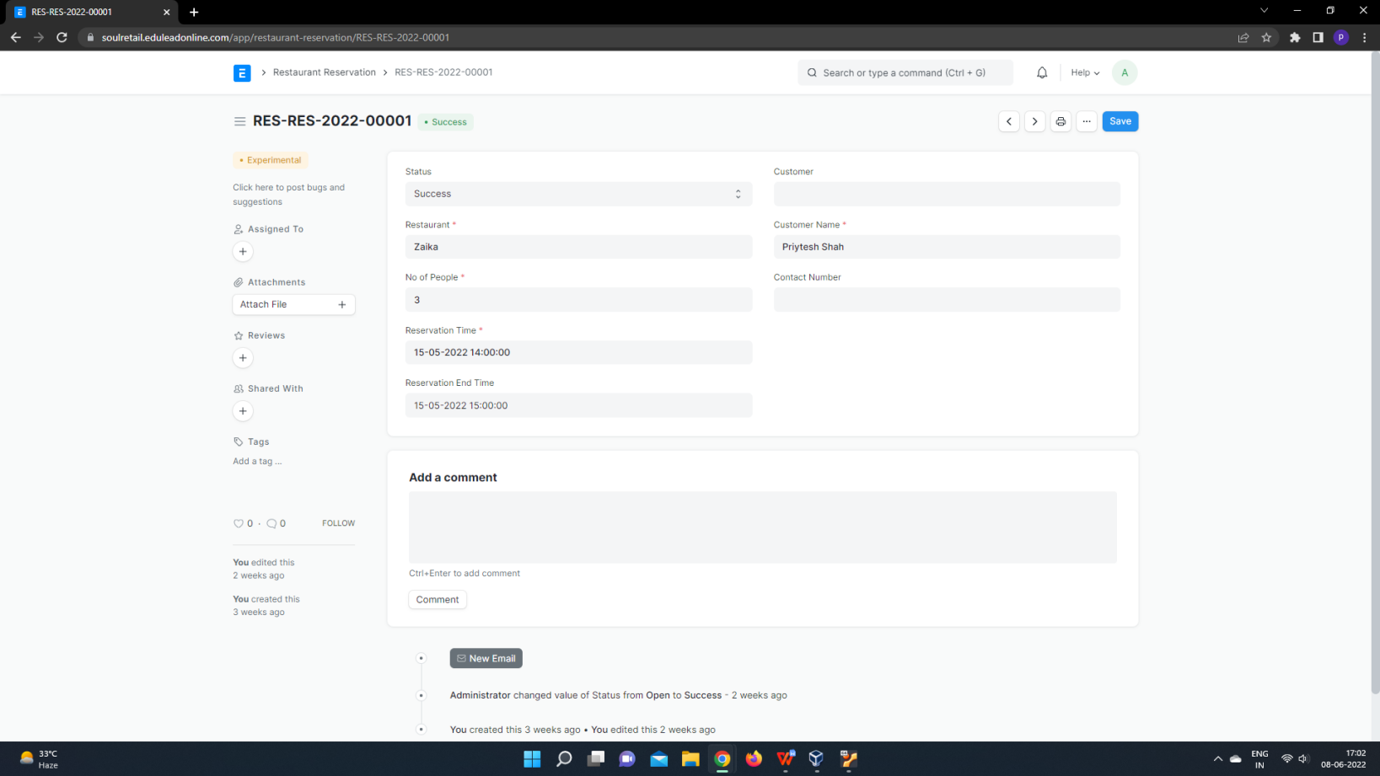

2. Enter Customer Name, Contact number, No of people and Reservation Time, Reservation End time for reservation.

4. save.